Factors Affecting Construction Project Performance: Case Study of Bharatpur Metropolitan
Shashi Bagale^{1*}, Niraj Bohara²
¹Department of Civil Engineering, Master of Science in Construction Management Program, United Technical College, Bharatpur-11, Nepal
²Department of Civil Engineering, Faculty of Civil Engineering, United Technical College, Bharatpur-11, Nepal
Emails: bgl.shashi@gmail.com (S. Bagale), boharanj@gmail.com (N. Bohara)
*Correspondence to: S. Bagale
Note: The overall length of the article should be 6000 to 7000 words excluding the references; Tables; and Figures
Abstract
The abstract should be a maximum of 225 words and must concisely include the motivation or general background, the research gap or issue addressed, the method used, and the key findings or conclusion.
Key Words: 4 to 5
- Introduction
The introduction must be coherent and concise, delineating a logical and clear problem statement, and it must present a current and credible literature review (no predatory journals). Do not be overly verbose and avoid unnecessary length or padding to reach the suggested word amount. The last paragraph must give the research aims clearly. Authors are welcome to use subsections (e.g., 2.1, 2.2) but should not go too deep (sticking with no more than 2.2.1 provided). Submit the paper as a single-column Word document that incorporates all figures and tables. The journal does not charge authors for color figures. The journal publishes accepted papers as open access and links them as articles on the college website.
- Materials and methods
The methods section should provide a clear and thorough description of the materials, equipment, and processes that would allow other researchers to reproduce your findings by following those same procedures. If applicable, the research area should be described first regarding its geographic, environmental, or contextual relevance, i.e., location description, relevant historical information, predominance of species in the area, etc.
Clearly and methodically present the methodology so that others can go through the same process and come up with similar results. Be meticulous and progressive in documenting experimental design, data collection processes, tools, and data analysis methods.
Use visual representations such as flowcharts, diagrams, or algorithms to promote clarity and understanding of your methods. To ensure accountability, include copies of all software, code, or programs used in your research in the appendices.
For the figures, charts and tables, appropriate captions have to be provided in the decided format as given.
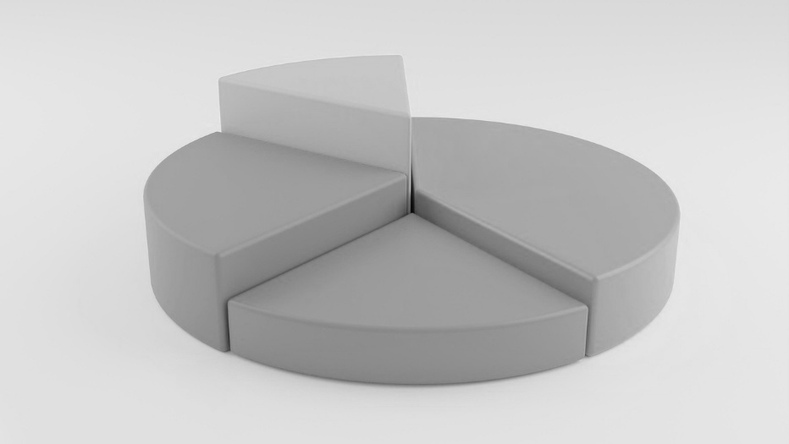
Figure 1 Pie chart showing composition

Table 1 List of materials used
SN | Particulars | Remarks

For equations, word’s equation format must be used with appropriate symbols as shown with equation number provided.
$A=\frac{{\left(1+r\right)}^{n}}{365-e^{-αt}}$ Eq 1
- Results and discussions
Clearly and systematically present your key findings in this section. Be sure to include data, tables, figures, etc., where appropriate to support your findings. After you have presented your results, provide a detailed discussion comparing your findings. Show how your findings further the state of knowledge and/or contribute to what is already known in the field. Clearly demonstrate how your studies contribute to or expand on the existing knowledge base or look at areas not previously explored.
- Conclusions
Please summarize the key findings of your study clearly and concisely. Discuss limitations encountered during the research and how these could impact the results. Provide practical suggestions for future research that builds on your work and addresses gaps in the research, unanswered questions, or difficulties encountered.
Conflict of interest
Declare 'No conflict of interest' if there are none.
Acknowledgements
Acknowledge any sources of funding, organizations, and individuals who contributed to the research but are not co-authors.
References
Use the Mendeley desktop app for Windows or Mac to manage citations. Use the Harvard referencing style in both Mendeley and Zotero. Download these free citation tools here:
- Zotero: https://www.zotero.org/download/
- Mendeley: https://www.mendeley.com/download-desktop-new/
Koirala, M.P. and Shahi, R.S. (2024) 'Examining the causes and effects of time overruns in construction projects promoted by rural municipalities in Nepal,' Evaluation and Program Planning, 105, p. 102436. https://doi.org/10.1016/j.evalprogplan.2024.102436.

Appendix
Include other codes, programs, or information in the appendix so they are easy to find and reference. Place these materials appropriately.

